Biometric Health Monitoring

**Software Engineering**

**14:332:452**

**Spring 2013**

**Group 12 Members**

Jose Villamor-Delgado

Cody Goodman

Jie Huang

Kyle Raucci

Florian Pranata



Contents

1.1 The Current Need for Fitness 3

1.2 Health Data Analysis 4

1.3 Making Fitness Fun 4

1.4 Making Fitness Affordable 5

1.5 Ease of Use 5

1.6 Glossary of Terms 6

2. System Requirements Analysis 6

2.1 Functional Requirements Table 7

2.2 Non-Functional Requirements Table 7

2.3 On Screen Appearance Requirements 8

3. Functional Requirements 9

3.1 Stakeholders 9

3.2 Actors and Goals 9

3.3 Use Cases UC - 1: Visitor Registration (Derived From REQ – 5, REQ – 7) 9

3.4 Use Case Diagram 12

12

3.5 Use Case Traceability Matrix 12

4. User Interface 17

Website User Interface 17

Android App User Interface 19

5. Domain Analysis 20

5.1 Domain Concept Definition Table 20

5.2 Association Definition Table 20

5.3 Attribute Definition Table 21

5.4 Domain Traceability Matrix 21

5.5 Mathematical Models 22

5.6 System Operation Contracts 22

Contribution Breakdown 23

References 24

**1. Customer Statement of Requirements**

## 1.1 The Current Need for Fitness

There are many reasons for which people strive to improve their health and fitness level, unfortunately there are equally as many reasons for which these same people do not reach their goals. Regardless of the reason for setting health and fitness goals, everyone could benefit from a system that addresses the most common deterrents that people face while trying to improve their health by embarking on a fitness program or regimen. A system that minimizes these deterrents would allow an individual to remain more focused on achieving their health goals. Some common problems faced when committing to improving one’s fitness are listed below.

* Self consciousness and insecurity
* Lack of health knowledge
* Lack of motivation
* Gym and training costs

There are currently two solutions commonly available to address these issues. The first being is to join a gym and to hire a trainer. Although this addresses many of the listed issues by providing the knowledge and motivational skills of a trainer, this solution can often be costly and often requires the participant to maintain regular appointments with a trainer and make routine trips to the gym. The main alternative to this is to utilize at home training exercises such as P90X, Insanity or simply jogging and eating right on your own. This alternative is often more cost effective and allows an individual to train in the comfort and security of their own home or around their neighborhood. The biggest drawback to this alternative is that without professional knowledge it can be difficult for someone to monitor their own progress and make effective changes to their diet and workout regimen. Even with the use of health monitoring devices and diet trackers it can be difficult and inconvenient for an individual to compile and analyze their fitness data on their own. What would really help in making fitness goals more easily attainable would be a single product that could bring together all the benefits of both solutions without the drawbacks. Such a product should do all or most of the following.

* Make fitness fun
* Make fitness affordable
* Make fitness easy to track
* Make it easy to analyze tracked data
* Provide relevant information and fitness suggestions based on progress and tracked data
* Make important health data easily and readily available

## 1.2 Health Data Analysis

As stated previously there is an assortment of monitoring devices capable of providing a user with various health and fitness data such as the Metria Wearable Sensor (below). While technology has been rapidly improving, the capabilities of such devices are expanding and can monitor and record data regarding everything from heart rate, to hours slept, to the amount a person perspires. Despite this improvement in medical technology, most of these devices are design to provide nurses and doctors with data on patients under their direct care. It is less common to have these devices directly provide the user with data on their own health, mainly because the user is unlikely to know the best course of action to take based upon such data. What would be very useful to health and fitness conscious consumers would be a system that in a sense cuts out the need for regular checkups by not only providing the user with pertinent data but providing professional analysis of long and short term data and making health and fitness suggestions based on a combination of recorded data and user inputs. For example the system may suggest that a user whose breaths per minute sharply rises with their number of steps take should exercise more often to increase their stamina. Another example would be combining a user provided symptom such as Chronic Fatigue Syndrome (CFS), with a long history of having less than 5 hours of sleep per night, to suggest that the person consider changing one’s sleep schedule to ensure a greater amount of sleep per day.

## 1.3 Making Fitness Fun

One of the most common reasons people fail to reach their fitness goals is a lack of motivation due to the large amount of effort fitness often requires for small increments of progress. Often people lose their motivation because they do not immediately begin to see results and decide that the large amount of effort is not worth the incremental gains. Two things people often look for when embarking on a fitness regimen are a way to make fitness fun and a way to track small improvements in order to keep one’s self motivated. One common way to do this is to work out in pairs or groups in order to observe each other’s progress and to keep each other motivated, however this is sometimes difficult if friend’s and partner’s schedules do not perfectly line up. With today’s heavy presence of social networking sites and mobile apps everyone uses sites such as Facebook and Twitter to tell their friends about everything from the meals they eat to the movies they go see. Being able to directly share fitness data and progress with friends on these social networking sites could potentially be a great motivator, allowing friends, family, coworkers, etc to post supporting comments to help maintain motivation. These social networking sites could also easily be used to turn fitness into a game amongst friends by providing a platform on which friends can compete with each other and brag or comment about their progress. Simple games could be created from data logged by various health monitoring devices such as pitting a group of friends against each other to see who can jog the longest distance in an hour, day, week, month, etc.

## 1.4 Making Fitness Affordable

One misconception that usually occurs is that people think that the only way to get fit is to exercise at the gym. Most of the time, this misconception turns people away from improving their fitness level, due to the monthly membership payment which is normally very costly, especially in the case of using a personal trainer. What most people often do not know is, maintaining the regularity along with a consistent diet is definitely enough to make running the most efficient way to improve fitness level. What we need is a system that can help people analyze their exercise routine and give useful feedbacks to help people reach their fitness goals, so that it can substitute the presence of a trainer. By providing such system, we believe we are able to offer significant benefits to general people, not only by just helping people get fit properly, but also cut down their expenses for such a simple goal of getting healthy. With just one health monitoring device and our application downloaded on their smartphone, we believe they can easily exercise and improve their health without even worrying about not progressing towards their fitness goal.

## 1.5 Ease of Use

When it comes to using a device, people will prefer a system that is simple and does not require too much of manual input. We are aware that a complicated system usually fails to appeal customers and provokes negative user experience, thus removing the software off the competition. Being easy to use is arguably one of the most important factors in making great software, regardless of how many functions the software offers, how sophisticated the system is, or even how beautiful the user interface looks. Obviously, our intention is to make software which is simple and easy to use without sacrificing any key functions, because we want our software to be used by not only the young generation, but everyone.

Our proposed system requires virtually no user manual input. We believe that this is very important to us, as we strive for great accessibility. As we said before, we want our software to be used by everyone, even physically disabled people. Given the fact that our software works in tandem with a health monitoring device, the user is only required to wear the device and set up their fitness goals, for example, their target weight. Our software will actively track, analyze, and provide instantaneous information about user’s progress. It will also constantly give useful feedbacks via notification, making it easy for user to receive suggestion to their training regime.

1.6 Glossary of Terms  
  
**Diet Trackers**  
A device that measures the amount of calorie intake and calories burned.  
**Heart Beat**  
A number of heartbeats per unit of time, typically expressed as beats per minute (bpm).  
**Symptom**  
Subjective evidence of disease or physical disturbance.  
**Chronic Fatigue Syndrome(CFS)**  
severe, continued tiredness that is not relieved by rest and is not directly caused by other medical conditions.  
**Personal Trainer**  
A fitness professional involved in exercise prescription and instruction. They motivate clients by setting goals and providing feedback and accountability to clients.  
**System**  
A set of health monitoring device, application, and user interface working together as a group.  
**User Experience (UX or UE)**  
User experience involves a person's emotions about using a particular product, system or service.

# 2. System Requirements Analysis

1. As a first time user, I want to be prompt to enter username, password, name, email, height, and weight.  
  
2. As a user, I want to load data from any computer or supported device.  
  
3. As an administrator, I want to access/delete any account.  
  
4. As a user, I want to modify/add information about myself.  
  
5. As a user, I want to insert calorie intake.  
  
6.  The system takes information/data from user.  
  
7. The system creates a graph to output to user.

|  |  |  |
| --- | --- | --- |
| 2.1 Functional Requirements Table | | |
| ID | **Priority Weight** | **Requirement** |
| REQ - 1 | 5 | System keeps a database for all users and their data |
| REQ – 2a  REQ – 2b  REQ – 2c  REQ – 2d | 5  5  5  5 | System can access, and compare user data  System can retrieve, and display user data  System can analyze and modify user data  System can receive input and store new data from user |
| REQ – 3a  REQ – 3b  REQ – 3c | 5  4  4 | System can calculate calories burned from user data  System can generate graphs and tables from user data  System can monitor calorie intake vs. calories burned |
| REQ - 4 | 4 | System can verify user login information |
| REQ - 5 | 4 | User is allowed to login |
| REQ - 6 | 4 | User is allowed to input data |
| REQ - 7 | 3 | User is allowed to change login information and settings |
| REQ - 8 | 2 | Administrator can access user data and account information |
| REQ - 9 | 2 | Administrator can delete or restrict user accounts |
| REQ - 10 | 2 | User can share data, graphs and tables to Social Networks |
| REQ – 11a  REQ – 11b | 1  1 | User can grant data access to other users  User can request data review from users labeled as health professionals |

|  |  |  |
| --- | --- | --- |
| 2.2 Non-Functional Requirements Table | | |
| ID | **Priority Weight** | **Requirement** |
| REQ -12 | 5 | System must not store data on user’s device |
| REQ - 13 | 5 | System must create and maintain a copy of user accounts and data in case of system failure or error |
| REQ - 14 | 4 | System must display data and analysis in clear, easy to read formats |
| REQ - 15 | 4 | System interface must be simple and easy to use |
| REQ – 16 | 4 | System must prevent dictionary attacks on user login |
| REQ - 17 | 3 | System should be self sufficient and require minimum maintenance |

## 2.3 On Screen Appearance Requirements

          This system consists of two working on-screen appearances that work in the same way but can be used on cross-platforms. The main on-screen appearance requirement is for the website which must abide by the rules and programming languages of html, css, javascript, and php. On the other platform, the android app must meet the requirements of the programming language of java.

**1. Home/Main Page** – gives the user the ability to create an account, view details about the webpage, log into their respective accounts

**2. Refresh** - allow user to refresh page if page is unresponsive or needs to load new information.

**3. Login**

**a. New user** - allows someone to register as a new user. Takes user to the registration page.

**b. Current members**- allows users login to their data.

**c. Lost password/username** - sends request to system to verify user and create new password or retrieve username account.

**d. Old members** - those who deleted their account could retrieve and restore old accounts

**4. Registration** – Allows new users to register into the database and create an account.

      a. Disclaimers, permissions and User Agreements

      b. User information registration

**5. Performance tracker** – users’ on screen output of their data and how well they are doing compared to the average user.

**6. Account Setting** - add/modify changes to account settings and/or information about user

**7. Account Retrieval/Lost** Account – Asks user for verification of identity in order to retrieve deleted accounts or retrieval of username/password.

**8. Help** - FAQ, send feedback, ask for help from administrators

**9. About App** - users can find more info (links) about health, training and tips, also information about how to use the app

# 3. Functional Requirements

## 3.1 Stakeholders

* Athletes
* Professional Sports Leagues
* Dietitians and Nutritionists
* Fitness Trainers
* Medical Practitioners
* Medical Device Companies

## 3.2 Actors and Goals

|  |  |
| --- | --- |
| Actor | Goals |
| Administrator – User with special permissions | To retrieve a client’s username and/or password from database  To ban, restrict, or delete other users |
| Client –Typical Registered User | To improve their own fitness and health  To input data about their diet, workouts, and health information  To access previously stored and analyzed data |
| Database – Non-human | To store user input data  To retrieve user input data  To facilitate comparison and analysis of user data |
| Monitoring Device | To track and record various aspects of a user’s health  To allow easy efficient uploading of user’s health data |
| Professional ­– User with special access to client data | To provide client with expert analysis of data  To provide client with professional services |
| Social Network | To provide client with a platform to share data with friends |
| Visitor – Unregistered User | To explore system capabilities  To view software product information |

## 3.3 Use Cases UC - 1: Visitor Registration (Derived From REQ – 5, REQ – 7)

* Allows a visitor to create a client account
* **Initiating Actor:** Visitor
* **Actor’s Goal:** To create a client account
* **Participating Actors:** Database
* **Precondition:** Visitor provides a currently unused username/password combination
* **Post-condition:** A new client account with the given username/password is created

**UC – 2: User Login** (Derived From REQ – 5)

* A user is able to login to their account by providing a valid username and password combination
* A user that provides an invalid username and password combination more than 5 times will be temporarily locked out of the system (Derived From REQ – 16)

**UC - 3:** **User Views Health/Fitness Data** (Derived From REQ – 2a, REQ – 2b)

* User is able to view previously entered data
* User is able to view analysis of previously entered data

**UC - 4:  Client Request for Professional Review** (Derived From REQ – 11a, REQ – 11b)

* Client is able to grant access of their data to Professional user accounts
* Client is able to request that a Health/Fitness Professional review their data/progress
* Client is able to allow their doctor or physician to access their data
* **Initiating Actor:** Client
* **Participating Actors:** Database, Professional
* **Precondition:** Client is logged in, client provides username of a valid professional account
* **Post-condition:** Client provided professional account can now access client’s data

**UC - 5: Client Password Change or Reset** (Derived From REQ – 7, REQ – 8)

* Client can change their password by providing the current password and the new password
* Client can request that their password be reset in the case that they have forgotten their password.

**UC - 6: Account Access for Administrators** (Derived From REQ – 8)

* An administrator such as an IT professional can access a user’s account in order to address any technical issues that the user may be experiencing.
* An administrator can put a temporary or permanent restriction on client access to their account or on a Professional’s account in the case that they misuse their account privileges.

**UC - 7: Client Input/Upload Data** (Derived From REQ – 2d, REQ - 6)

* Client can input new data to their account to be stored on the database by either inputting information manually or by directly uploading data from supported health monitoring devices.

**UC - 8: Linking Client Accounts to Social Networks** (Derived From REQ – 10)

* Allow a client to permanently link their account with a supported social network account

**UC – 9: Sharing Client Data/Graphs/Tables to Social Networks** (Derived From REQ – 10)

* Allow a client to share fitness data to a linked social networking site
* Allow a client to share generated graphs/tables to a linked social networking site

**UC – 10: Deletion of Client Account** (Derived From REQ – 9)

* An Administrator can delete an account from the database

**UC – 11: Restoration of User Account/Data** (Derived From REQ – 8, REQ – 13)

* An Administrator can restore a user’s account/data from a backup copy if there is a problem with the client’s account

**UC – 12: Generate/Refresh Graphs and Tables** (Derived From REQ – 3, REQ – 6)

* Client can generate analysis graphs and/or tables based on new input data
* Client can refresh existing graphs and/or tables to include new input data
* **Initiating Actor:** Client
* **Participating Actor:** Database
* **Preconditions:** Client is logged in, and Client has previously entered data
* **Post-conditions:** Graphs and tables are generated from Client’s data

## 3.4 Use Case Diagram

## C:\Users\Cody\Desktop\UseCaseDiagram1.png

Figure 3.4: Use Case Diagram

|  |  |  |  |  |  |  |  |  |  |  |  |  |  |  |  |  |  |
| --- | --- | --- | --- | --- | --- | --- | --- | --- | --- | --- | --- | --- | --- | --- | --- | --- | --- |
| 3.5 Use Case Traceability Matrix | | | | | | | | | | | | | | | | | |
| **REQ#** | **1** | **2** | **3** | **4** | **5** | **6** | **7** | **8** | **9** | **10** | **11** | **12** | **13** | **14** | **15** | **16** | **17** |
| **UC-1** |  |  |  |  | **X** |  | **X** |  |  |  |  |  |  |  |  |  |  |
| **UC-2** |  |  |  |  | **X** |  |  |  |  |  |  |  |  |  |  |  |  |
| **UC-3** |  | **X** |  |  |  |  |  |  |  |  |  |  |  |  |  |  |  |
| **UC-4** |  |  |  |  |  |  |  |  |  |  | **X** |  |  |  |  |  |  |
| **UC-5** |  |  |  |  |  |  | **X** | **X** |  |  |  |  |  |  |  |  |  |
| **UC-6** |  |  |  |  |  |  |  | **X** |  |  |  |  |  |  |  |  |  |
| **UC-7** |  |  | **X** |  |  | **X** |  |  |  |  |  |  |  |  |  |  |  |
| **UC-8** |  |  |  |  |  |  |  |  |  | **X** |  |  |  |  |  |  |  |
| **UC-9** |  |  |  |  |  |  |  |  |  | **X** |  |  |  |  |  |  |  |
| **UC-10** |  |  |  |  |  |  |  |  | **X** |  |  |  |  |  |  |  |  |
| **UC-11** |  |  |  |  |  |  |  | **X** |  |  |  |  | **X** |  |  |  |  |
| **UC-12** |  |  | **X** |  |  | **X** |  |  |  |  |  |  |  |  |  |  |  |

**3.6 System Sequence Diagrams**

**UC – 2: User Login**

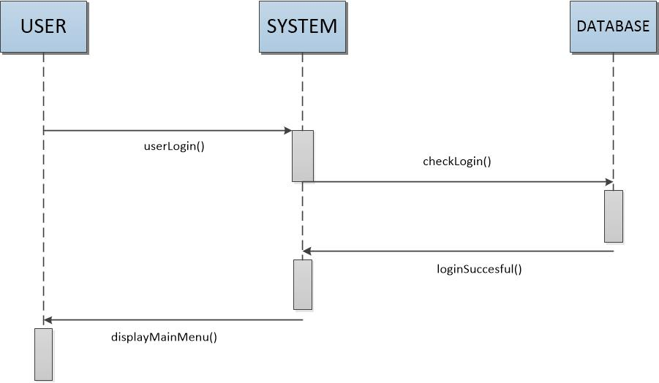

**Alternate Case**

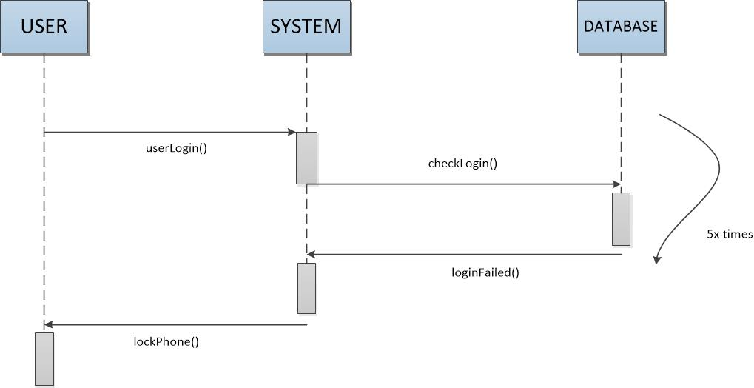

**UC - 3: Client Views Health/Fitness Data**

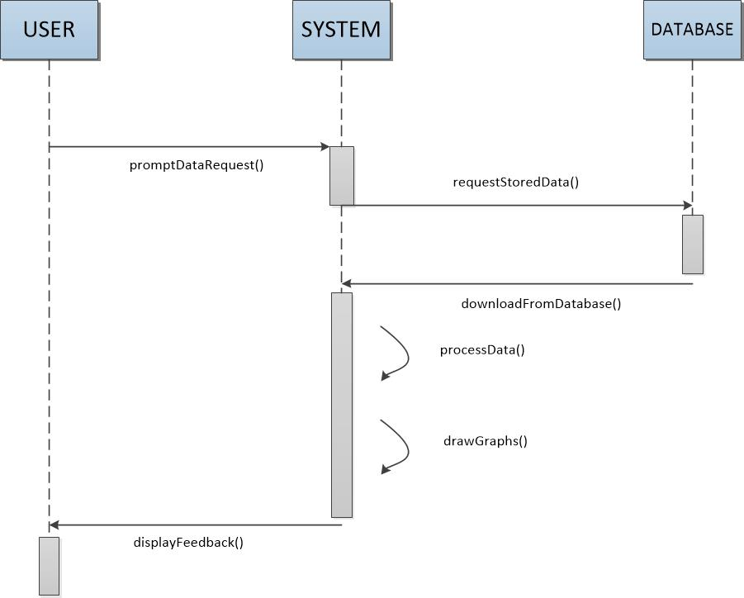

**UC - 4: Client Request for Professional Review**

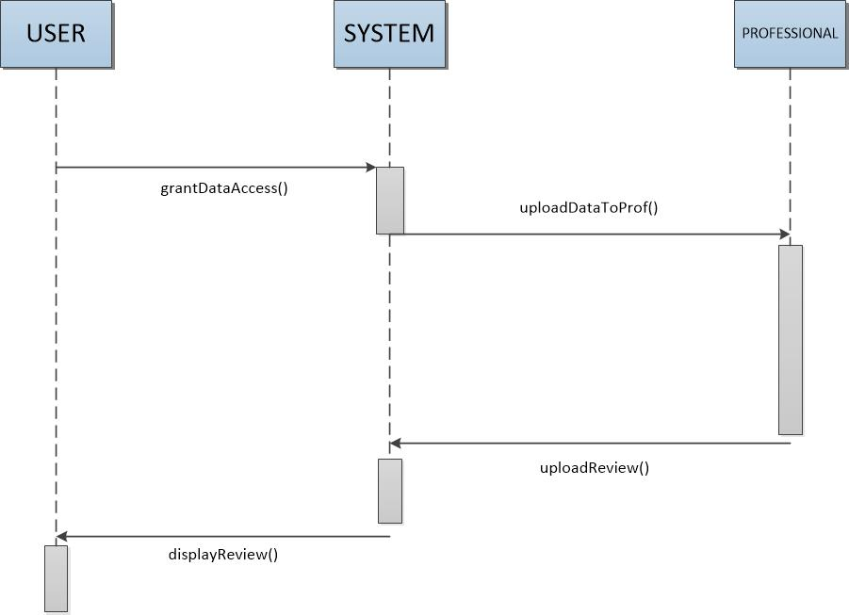

**UC - 7: Client Input/Upload Data**

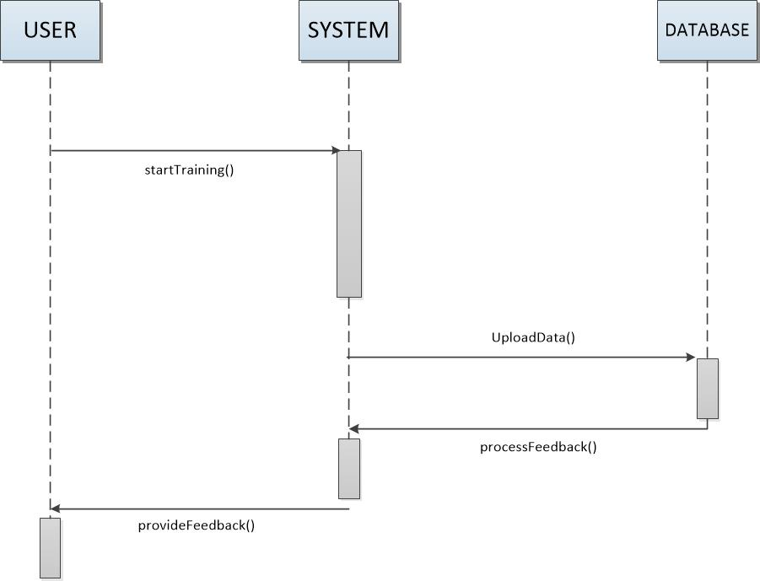

**UC – 9: Sharing Client Data/Graphs/Tables to Social Networks**

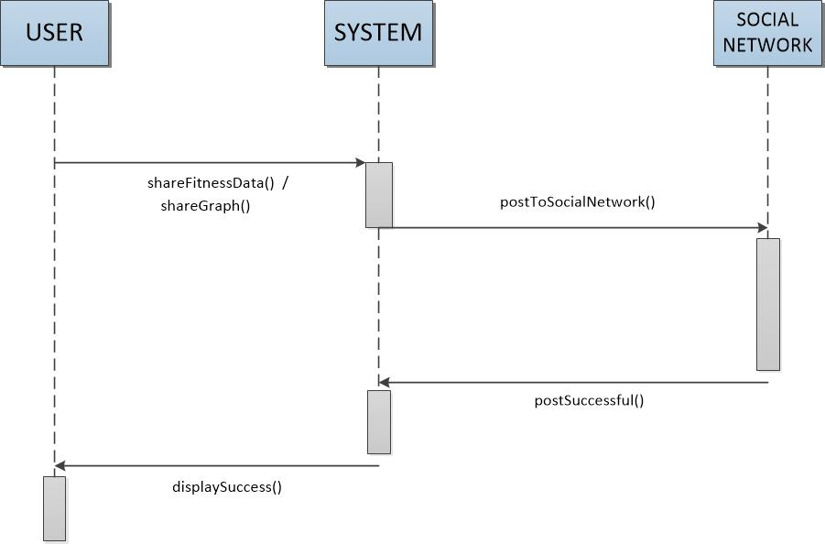

**UC – 12: Generate/Refresh Graphs and Tables**

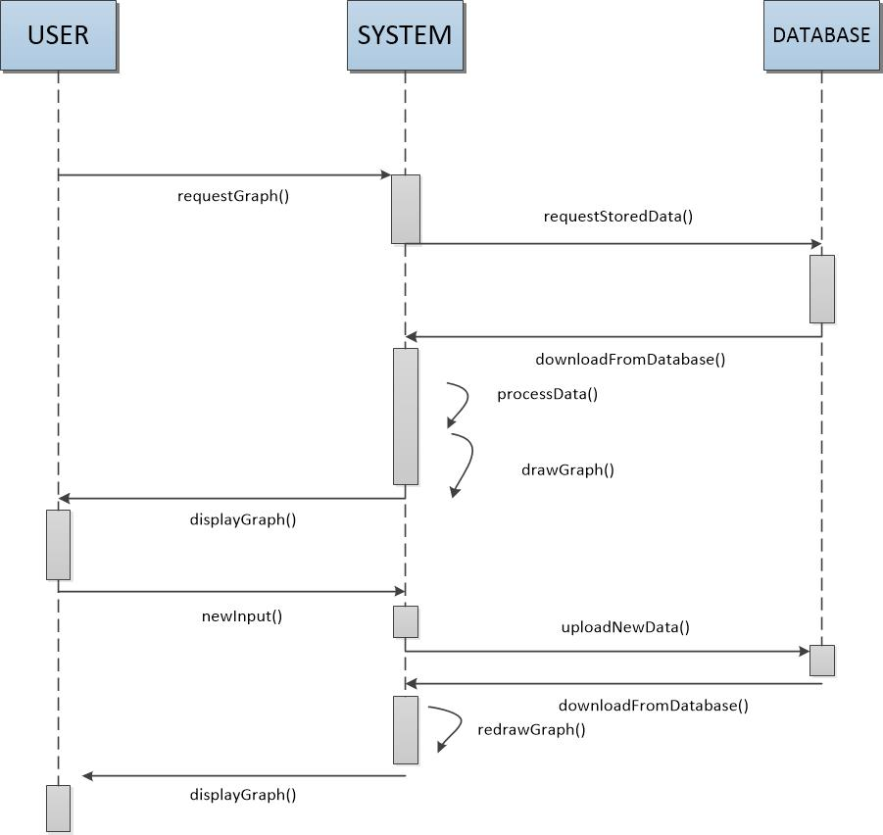

# 4. User Interface

### Website User Interface

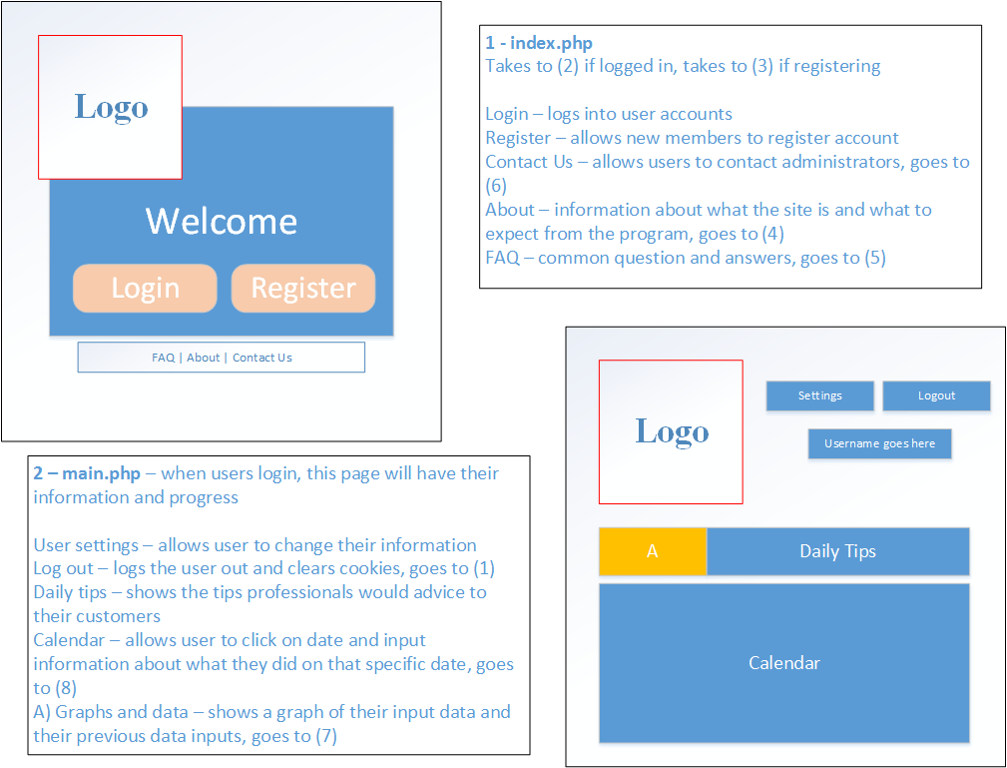

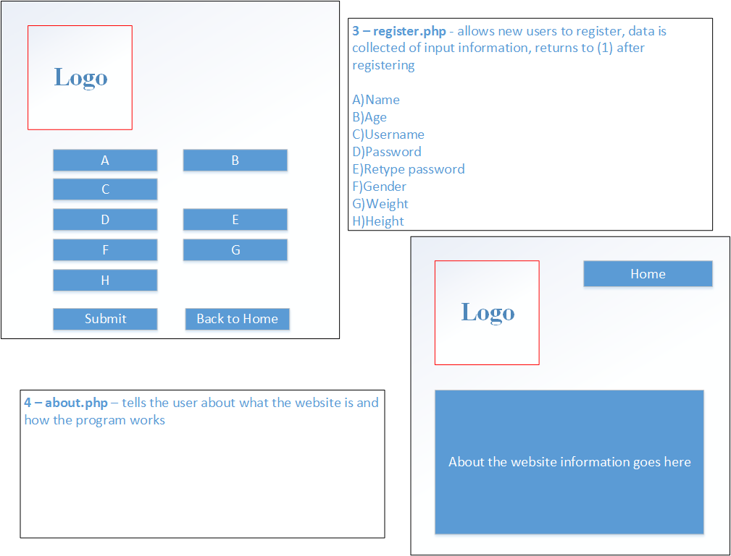

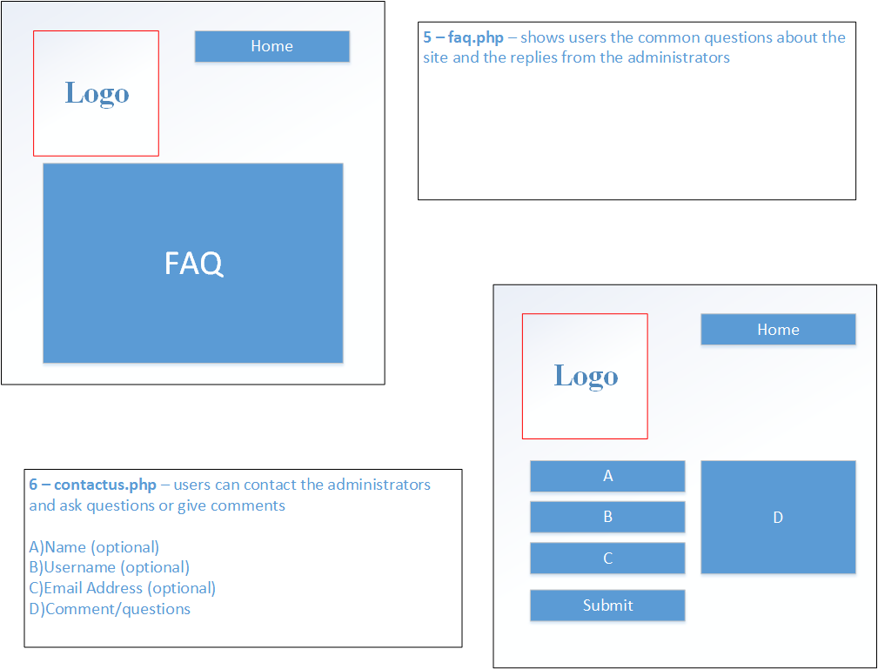

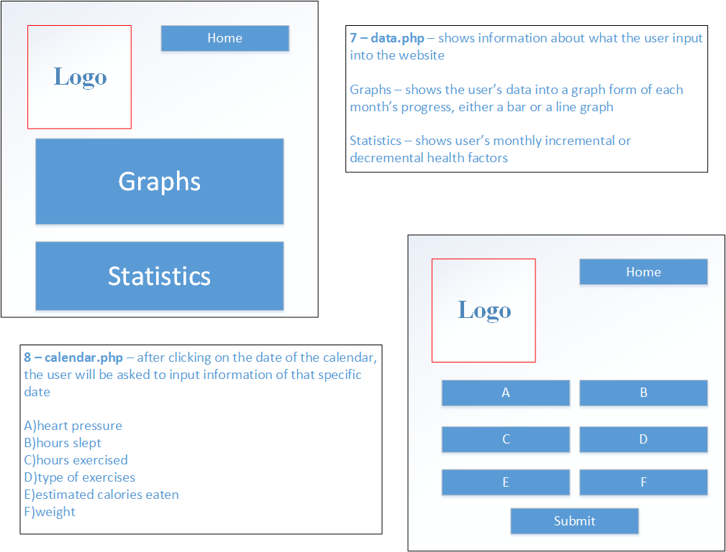

### Android App User Interface

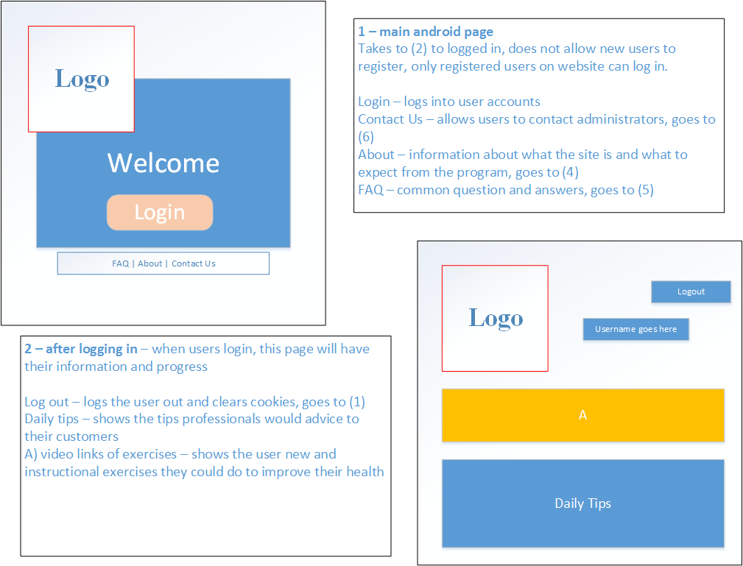

# 5. Domain Analysis

|  |  |  |  |
| --- | --- | --- | --- |
| 5.1 Domain Concept Definition Table | | | |
| Responsibility | **Type** | **Concept** | **Use Case** |
| Create new user account | D | User Account Creator | UC – 1 Visitor Registration |
| Verify User login information is correct |  | Login Verifier | UC – 2 User Login |
| Display user’s data and graphs | D | User Account Viewer | UC – 3 User Views Health/Fitness Data |
| Grant client data viewing access to designated professional account. | D | Professional Review Interface | UC – 4 Client Request for Professional Review |
| Allow administrator to access a client’s account in the case of technical difficulties. | D | Tech Services Interface | UC – 6 Account Access for Administrators |
| Change a user’s password, or email a new randomly generated password to user’s register email address. | D | Account Password Manager | UC – 5 Client Password Change or Reset |
| Receive and store new data input from user | D | Account Data Manager | UC – 7 Client Input/Upload Data |
| Upload data from health monitoring device | D | Device Data Up-Loader | UC – 7 Client Input/Upload Data |
| Create external backup of database | D | Database Backup |  |
| Link Client account to social network | D | Social Network Linking Interface | UC – 8 Linking Client Accounts to Social Networks |
| Post client data/graphs/tables to social networks | D | Social Network Sharing Interface | UC – 9 Sharing Client Data/Graphs/Tables to Social Networks |
| Delete invalid user accounts, and ban registered email addresses of malicious users | D | Admin Account Manager | UC – 10 Deletion of User Account |
| Restore user accounts and account data and information from database backup | D | Database Restorer | UC – 12 Restoration of User Account/Data |
| Analyze client data and generate relevant charts/tables | D | Data Analyzer | UC – 12 Generate/Refresh Graphs and Tables |

|  |  |  |
| --- | --- | --- |
| 5.2 Association Definition Table | | |
| Concept Pair | **Association Description** | **Association Name** |
| User Account Creator  Login Verifier | User Account Creator utilizes the login verifier to check if given username/password combination is valid and currently available. | User Registration |
| Account Data Manager  Device Data Up-Loader | Data Analyzer and Account Data Manager both allow the system to receive input data from the user | Data Input |
| Data Analyzer  Account Data Manager | Data Analyzer implements the data received from the Account Data Manager in analysis and graph/table creation | Data Analysis |
| Professional Review Interface  User Account Viewer | The Professional Review Interface grants special permissions to a designated Professional account to utilize the User Account Viewer to view a users data | Professional Review |
| Social Network Linking Interface  Social Network Sharing Interface | The Social Network Shaing Interface posts user data to accounts that have been linked through the Social Network Linking Interface | Social Networking |
| Database Backup  Database Restorer | User accounts can be restored by the Database Restorer using backups created by the Database Backup | Database Memory Management |

|  |  |  |
| --- | --- | --- |
| 5.3 Attribute Definition Table | | |
| Concept | **Attributes** | **Attribute Description** |
| Account Data Manager | Data Access and Storage | Read/Write from/to database |
| Device Data Up-Loader |
| User Account Creator |
| User Account Viewer |
| Login Verifier |
| Data Analyzer | Data Analysis | Performs operations on existing data |
| Social Network Linking Interface | Social Networking Interface | Facilitates interactions between system and social networks |
| Social Network Sharing Interface |
| Admin Account Manager | Account Settings Interface | Utilities for technical services |
| Account Password Manager |
| Database Backup | Database Management Interface | Maintains a copy of the database for backup purposes |
| Database Restorer |
| Tech Services Interface | User Interaction Interface | Grants special permissions for interactions between users |
| Professional Review Interface |

|  |  |  |  |  |  |  |  |  |  |  |  |  |  |  |
| --- | --- | --- | --- | --- | --- | --- | --- | --- | --- | --- | --- | --- | --- | --- |
| 5.4 Domain Traceability Matrix | | | | | | | | | | | | | | |
| Use Case | **Domain Concept** | | | | | | | | | | | | | |
| User Account Creator | Login Verifier | User Account Viewer | Professional Review Interface | Account Password Manager | Tech Services Interface | Account Data Manager | Device Data Up-Loader | Social Network Linking Interface | Social Network Sharing Interface | Admin Account Manager | Database Restorer | Database Backup | Data Analyzer |
| UC:1 | **X** | **X** |  |  |  |  |  |  |  |  |  |  |  |  |
| UC:2 |  | **X** |  |  |  |  |  |  |  |  |  |  |  |  |
| UC:3 |  |  | **X** |  |  |  |  |  |  |  |  |  |  |  |
| UC:4 |  |  |  | **X** |  |  |  |  |  |  |  |  |  |  |
| UC:5 |  |  |  |  | **X** |  |  |  |  |  |  |  |  |  |
| UC:6 |  |  |  |  |  | **X** |  |  |  |  |  |  |  |  |
| UC:7 |  |  |  |  |  |  | **X** | **X** |  |  |  |  |  |  |
| UC:8 |  |  |  |  |  |  |  |  | **X** |  |  |  |  |  |
| UC:9 |  |  |  |  |  |  |  |  |  | **X** |  |  |  |  |
| UC:10 |  |  |  |  |  |  |  |  |  |  | **X** |  |  |  |
| UC:11 |  |  |  |  |  |  |  |  |  |  |  | **X** | **X** |  |
| UC:12 |  |  |  |  |  |  |  |  |  |  |  |  |  | **X** |

## 5.5 Mathematical Models

Calculation of Body Mass Index (BMI): $BMI= 703*{\left(\frac{weight(lb)}{height(in)}\right)}^{2}$

## 5.6 System Operation Contracts

**User Account Creator**

* **Preconditions**
  + User chose a username that is currently not in use
  + User chose a valid password
  + User provided a valid email address
  + User’s email address is not currently linked to an existing account
* **Post-conditions**
  + A new account with the user supplied information is created

**Login Verifier**

* **Preconditions**
  + User enters valid username
  + User enters corresponding password
* **Post-conditions**
  + User is logged in

**Professional Review Interface**

* **Preconditions**
  + Client is Logged in
  + Client enters valid professional account username
* **Post Conditions**
  + Professional account is able to access user’s data
  + Professional’s account email received a notice informing them of the review request

**Data Analyzer**

* **Preconditions**
  + Client is logged in
  + Client data exists
* **Post-conditions**
  + Graphs illustrating analysis of client’s data are generated for display

# Contribution Breakdown

|  |  |  |  |  |  |  |
| --- | --- | --- | --- | --- | --- | --- |
| Contribution Breakdown Report #1 | | | | | | |
| Task | **Cody** | **Kyle** | **Florian** | **Jie** | **Jose** | **Total** |
| Summary of Changes | 20% | 20% | 20% | 20% | 20% | 100 |
| Sec 1: Customer Statement of Requirements | 75% | - | 25% | - | - | 100 |
| Sec 2: Glossary of Terms | - | - | 100% | - | - | 100 |
| Sec 3: System Requirements | 50% | - | 20% | 10% | 20% | 100 |
| Sec 4: Functional Requirements Specification | 70% | - | - | - | 30% | 100 |
| User Interface Specification | - | - | - | 100% | - | 100 |
| Effort Estimation | - | 35% | 30% | - | 35% | 100 |
| Sec 5: Domain Analysis | 100% | - | - | - | - | 100 |
| Sec 6: Plan of Work | - | 100% | - | - | - | 100 |
| Sec 7: References | - | - | - | 100% | - | 100 |

# References

* 1. **"Adult Obesity Facts."** *Cdc.gov*. Centers for Disease Control and Prevention, 13 Aug. 2012. Web. 08 Oct. 2012. <http://www.cdc.gov/obesity/data/adult.html>.
  2. **"Google Code University: Android."** *Code.google.com*. Google, n.d. Web. 23 February 2013. <http://code.google.com/edu/android/index.html>.
  3. **"Heart Diseases & Disorders."** *Hrsonline.org*. Heart Rhythm Society, n.d. Web. 23 Feb. 2013. <http://www.hrsonline.org/Patient‐Resources/Heart‐Diseases‐Disorders>.
  4. **"Heart Rate."** *Wikipedia*. Wikimedia Foundation, 10 Aug. 2012. Web. 23 Feb. 2013. <http://en.wikipedia.org/wiki/Heart_rate>.
  5. McGee, Marianne Kolbasuk. **"11 Telemedicine Tools Transforming Healthcare."** *Informationweek*. InformationWeek, 23 Mar. 2012. Web. 23 Feb. 2013. <http://www.informationweek.com/healthcare/mobile‐wireless/11‐telemedicine‐tools‐transforminghealt/232602982>.
  6. **"Wearable Wireless Medical Devices to Top 100 Million Units Annually by 2016, ABI Research."** *Wearable Wireless Medical Devices to Top 100 Million Units Annually by 2016, ABI Research*. Business Wire, 17 Aug. 2011. Web. 08 Oct. 2012. <http://www.businesswire.com/news/home/20110817006223/en/Wearable‐Wireless‐Medical‐Devices‐Top‐100‐Million>.